Hospital Management System

Abstract
Our project Hospital Management system is about registration of patients, storing details of patients into the system and booking appointments of them with doctors. In our software gives unique id forever patient and stores the data of every patient and the staff automatically. User will be able to search availability of a doctor and patient detail using id. The entry point of the Hospital Management System is login using username and password. This all information is accessible by an administrator or receptionist and they can add data into database. The data can be retrieved easily. The interface is very user-friendly. The data processing is very fast and well protected for personal use. It is having mainly two modules, one is at Administration and user, i.e., of patients and doctors. The Application maintains authentication in order to access the application. Administrator task includes managing doctors information, patient’s information. To achieve this, aim a database was designed for patient and other is for doctor which is the admin can access. The user complaints are referred by authorities. The Patient modules include checking appointments, prescription.
Keywords : Hospital Management System, Patient Registration, Appointment Booking, Unique Patient ID, Doctor Availability, Authentication, Administrator Module, Patient Module, Doctor Module, Database Management, User-Friendly Interface, Secure Data Processing

Existing system
Traditional hospital management systems rely on manual or semi-automated processes for user registration, document handling, and identity verification. Aadhar card data is manually input and vulnerable to human error or misuse. There’s limited or no automated mechanism for securely managing sensitive patient data, especially in terms of masking personal identifiers.
Disadvantages:
- Manual data entry can lead to errors and inconsistencies.
- No privacy mechanism to protect sensitive Aadhar information.
- Delayed processing and coordination between patients, doctors, and insurance users.
Proposed system
The proposed system automates hospital management using YOLOv11-based Aadhar card detection and OCR to extract Aadhar numbers securely. It includes role-based logins for patients, doctors, insurance agents, and admins, ensuring data privacy through masking and unmasking of sensitive data, along with automated profile creation, appointment booking, document upload, prescription management, and billing.
Advantages:
- Automated Aadhar detection and OCR ensures fast and accurate data extraction.
- Role-based masking/unmasking provides better privacy control for sensitive data.
- Seamless integration of appointments, prescriptions, and billing improves overall efficiency.
Modules Description:
To implement this project, we have designed following modules
• New User Sign Up
- Allows new users (Patients, Doctors, Insurance Agents) to register with the system by entering their personal and professional details. These details are stored in the database for future login and access.
• Patient Module
- Patients can log in, create their medical profile by uploading medical history documents and an Aadhar card.
- The system uses YOLOv11 to detect the Aadhar card number region and applies OCR to extract the number.
- Extracted Aadhar data is masked when viewed by doctors and unmasked only for admin.
- Patients can view available doctors, book appointments, and access their prescriptions and billing details.
• Doctor Module
- Doctors can log in and view appointments scheduled for the current day.
- They can view patient history, download uploaded documents, and generate prescriptions.
- Aadhar card numbers are shown in a masked format for privacy.
• Insurance Module
- Insurance company users can log in and search billing details by entering patient names.
- They can verify the bill amount and patient identity without accessing full sensitive data.
• Admin Module
- Admins can log in and view all user profiles, appointments, prescriptions, and billing records.
- Admins have full access, including viewing unmasked Aadhar cards and managing system-wide data.
• YOLOv11 + OCR Integration
- Integrates the YOLOv11 CNN algorithm to detect the Aadhar number region in uploaded cards.
- Optical Character Recognition (OCR) is then applied to extract the number for storage and further verification.
- This ensures accuracy and automates the verification process securely.
• Billing & Prescription Generation
- Once a doctor creates a prescription, an automated bill is generated for the patient.
- These can be accessed by both the patient and insurance users for verification and processing.
• Security and Masking System
- Implements role-based access control where sensitive Aadhar card numbers are masked for doctors and unmasked only for admins.
- Ensures privacy and data protection in compliance with healthcare data policies.

System Architecture:
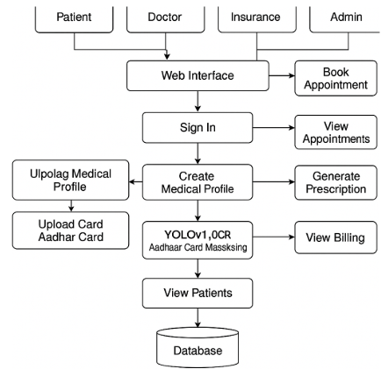

HARDWARE & SOFTWARE REQUIREMENTS:
HARDWARE REQUIRMENTS:
- Processor : Intel I3(min)
- Hard Disk : 500 GB (min).
- Ram : 4 GB (min).
SOFTWARE REQUIRMENTS:
- Operating system : Windows 10 (min)
- Coding Language : python 3.7.0

